NOTICE OF PUBLIC MEETING
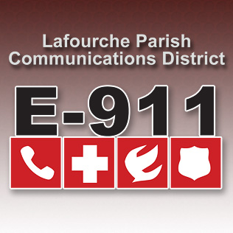
LAFOURCHE PARISH COMMUNICATIONS DISTRICT

Date: October 5, 2017
Time: 1:00 p.m.
Location: L.P.C.D. PSAP / Conference Room
111 Dunkleman Dr.
Raceland, LA 70394

BOARD MEETING AGENDA

- Meeting called to order

- Pledge of Allegiance to the Flag

- Roll call by Valerie Adams

- Comments from the Public

- Minutes July 6, 2017 Board Meeting

- Secretary/Treasurer Report
  - July, August, September 2017 Financial Reports
  - Resolution 2017-10-01 Iberia Bank
  - Resolution 2017-10-02 Capital One & JP Morgan Chase Bank
  - Proposed 2017 Amended Budget
  - Proposed 2018 Budget

- Building Report

- New Business
  - Zuercher Cad System proposal
  - Election of officers 2017-2018

- Old Business

- Chairman’s Report

- Administrator’s Report
  - July, August, & September PSAP Reports 2017 PSAP Reports
  - EBS Annual Maintenance October 11, 2017-18

- Comments from Board Members

- Adjourn

