NOTICE OF PUBLIC MEETING
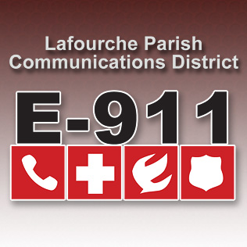
LAFOURCHE PARISH COMMUNICATIONS DISTRICT

Date: November 4, 2021
Time: 1:00 p.m.
Location: L.P.C.D. PSAP / Conference Room
111 Dunkleman Dr.
Raceland, LA 70394

BOARD MEETING AGENDA

- Meeting called to order by Chairman Boudreaux

- Pledge of Allegiance to the Flag

- Roll call by Valerie Adams

- Comments from the Public

- Minutes June 3, 2021 Board Meeting

- Secretary/Treasurer Report
  - September-October Financial Reports
  - Proposed 2021 Amended Budget
  - Proposed 2022 Budget

- Building Report

- New Business

- Old Business

- Chairman’s Report

- Administrator’s Report
  - Intrado upgrade
  - January-October 2021 PSAP Reports
  - Street Resolution 2021-11-01
- Comments from Board Members

- Adjourn

