NOTICE OF PUBLIC MEETING
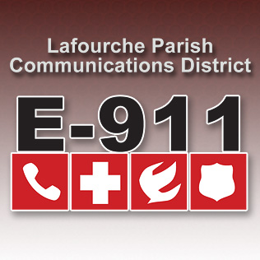
LAFOURCHE PARISH COMMUNICATIONS DISTRICT

Date: January 9, 2018
Time: 1:00 p.m.
Location: L.P.C.D. PSAP / Conference Room
111 Dunkleman Dr.
Raceland, LA 70394

BOARD MEETING AGENDA

- Meeting called to order by Chairman Vedros

- Pledge of Allegiance to the Flag

- Roll call by Valerie Adams

- Comments from the Public

- Minutes December 7, 2017 Board Meeting

- Secretary/Treasurer Report
  - December 2017 Financial Reports
  - Louisiana Legislative Auditor Compliance Questionnaire
  - Bourgeois Bennett Auditor Compliance Questionnaire

- Building Report

- New Business

- Old Business

- Chairman’s Report

- Administrator’s Report
  - December 2017 PSAP Reports

- Comments from Board Members

- Adjourn

