NOTICE OF PUBLIC MEETING
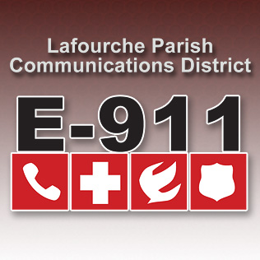
LAFOURCHE PARISH COMMUNICATIONS DISTRICT

Date: January 7, 2021
Time: 1:00 p.m.
Location: L.P.C.D. PSAP / Conference Room
111 Dunkleman Dr.
Raceland, LA 70394

BOARD MEETING AGENDA

- Meeting called to order by Chairman Boudreaux

- Pledge of Allegiance to the Flag

- Roll call by Valerie Adams

- Comments from the Public

- Minutes December 3, 2020 Board Meeting

- Secretary/Treasurer Report
  - December 2020 Financial Reports
  - Louisiana Legislative Auditor Compliance Questionnaire
  - Bourgeois Bennet Auditor Compliance Questionnaire

- Building Report

- New Business

- Old Business

- Chairman’s Report

- Administrator’s Report
  - December 2020-PSAP Reports

- Comments from Board Members

- Adjourn

