NOTICE OF PUBLIC MEETING
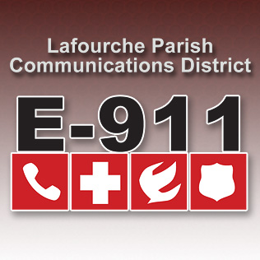
LAFOURCHE PARISH COMMUNICATIONS DISTRICT

Date: December 7, 2017
Time: 1:00 p.m.
Location: L.P.C.D. PSAP / Conference Room
111 Dunkleman Dr.
Raceland, LA 70394

Public Hearing 2018 Proposed Budget
Board meeting will be called to order immediately following the public hearing.

BOARD MEETING AGENDA

- Meeting called to order

- Pledge of Allegiance to the Flag

- Roll call by Valerie Adams

- Comments from the Public

- Minutes October5, 2017 Board Meeting

- Secretary/Treasurer Report
  - October & November 2017 Financial Reports
  - Proposed 2017 Amended Budget
  - Proposed 2018 Budget
  - Louisiana Legislative Auditor Statewide Agreed-Upon Procedures

- Building Report

- New Business

- Old Business

- Chairman’s Report

- Administrator’s Report

  - Street Resolution 2017-12-01
  - October and November PSAP Reports 2017 PSAP Reports

- Comments from Board Members

- Adjourn

