NOTICE OF PUBLIC MEETING
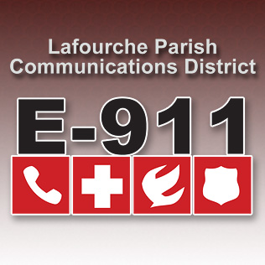
LAFOURCHE PARISH COMMUNICATIONS DISTRICT
Public Hearing 2022 Proposed Budget

Date: December 2, 2021
Time: 1:00 p.m.
Location: L.P.C.D. PSAP / Conference Room
111 Dunkleman Dr.
Raceland, LA 70394

BOARD MEETING AGENDA

- Meeting called to order by Chairman Boudreaux

- Pledge of Allegiance to the Flag

- Roll call by Valerie Adams

- Comments from the Public

- Minutes November 4, 2021 Board Meeting

- Secretary/Treasurer Report
  - November Financial Reports
  - Proposed 2021 Amended Budget
  - Proposed 2022 Budget
  - Louisiana Legislative Auditor Statewide Agreed-Upon Procedures

- Building Report

- New Business

a.)2022 Election of Officers
    - Chairman
    - Vice Chairman
    - Secretary
  - MOU Funding Agreement Louisiana PA
- Old Business

- Chairman’s Report

- Administrator’s Report
  - Street Resolution 2021-12-01
  - 2022 Meeting Dates
  - November 2021 PSAP Reports

- Comments from Board Members

- Adjourn

