NOTICE OF PUBLIC MEETING
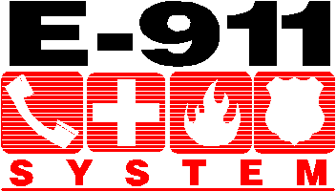
LAFOURCHE PARISH COMMUNICATIONS DISTRICT

Date: April 28, 2016
Time: 1:00 p.m.
Location: L.P.C.D. PSAP / Conference Room
111 Dunkleman Dr.
Raceland, LA 70394

BOARD MEETING AGENDA

- Meeting called to order by Chairman Vedros

- Pledge of Allegiance to the Flag

- Roll call by Valerie Adams

- Comments from the Public

- Minutes January 21, 2016 Board Meeting

- Secretary/Treasurer Report
  - Bourgeois Bennett Annual Audit Report
  - January, February and March 2016 Financial Reports

- New Business
  - Resolution 2016-4-1 Wireline increase
  - Intrado Quote 10570 Power Locate
  - Console Cleaning Services Quote 1825
  - Johnson Control Annual Maintenance Estimate 1-CX7JJFB $7,350
  - 2016 Legislation HB 805 and HB 678

- Old Business

- Chairman’s Report

- Administrator’s Report
  - January, February, and March 2016 PSAP Reports

- Comments from Board Members

- Adjourn

