NOTICE OF PUBLIC MEETING
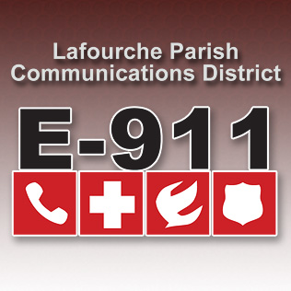
LAFOURCHE PARISH COMMUNICATIONS DISTRICT

Date: June 3, 2021
Time: 1:00 p.m.
Location: L.P.C.D. PSAP / Conference Room
111 Dunkleman Dr.
Raceland, LA 70394

BOARD MEETING AGENDA

- Meeting called to order by Chairman Boudreaux

- Pledge of Allegiance to the Flag

- Roll call by Valerie Adams

- Comments from the Public

- Minutes January 7, 2021 Board Meeting

- Secretary/Treasurer Report
  - January 2021-May 2021 Financial Reports
  - Audit Report

- Building Report

- New Business
  - Avexon Quote 1808282051 $2,730
- Old Business

- Chairman’s Report

- Administrator’s Report
  - Employee Vacation Time
  - Street Resolution 2021-06-1
  - Pictometry Agreement
- Comments from Board Members

- Adjourn

